Ideas
These were moved here from the Projects documentation, to the System documentation, to integrate them with the System documentation. Remaining ideas should be moved back to the Projects documentation after that. The Projects documentation is where Ideas belong.

Interfaces
The interfaces an object supports are interesting. It’s also interesting to know if an interface is supported by an object. Ofcourse you could derive that from the first data, but that’s not the fastest.

Microsoft makes it possible for client modules to connect to server modules that the client didn’t know before, but simply supports some interface. Hmmm… well.. the interface needs to be defined somewhere in another module so … it had to be compiled with the module defining the interface and it can go look for the interface in any component and class it likes.

Hmm there are more Com J Core comparisons to be made.

No. Com also allows you to call interfaces that the client module isn’t compiled with.

Ik heb mijn vraagtekens bij de toepasbaarheid daarvan.

Using an interface is only for a couple of possible purposes:
(I’m not sure this list is complete)
- Support a sure set of members
- Participate in existing systems
- Derived from another class

< An object has one or more interfaces. >
< an object reference can be assigned one interface or no interface at all. >

Computer Language,
2008-06-08

The term ‘member’ can best be introduced in the interface section.

JJ

Interfaces,

Subdividing the commands from different site into different interfaces of an object, is a separate issue to address.

JJ

Class method interfaces,

Perhaps class method interfaces also need to be a separate coding
principle now.
But a lot of topics will be explained before explaining class method
interfaces.
Don't call them method interfaces, because a method itself has an interface,
so that term is in use already.

JJ

Out of Commands & Classes Loosely Coupled
2008-09-23
These sections came out of the old document Commands & Classes Loosely Coupled.

One thing about these sections is not right anymore. Spontaneous extension of interfaces does not only apply to commands. It also applies to backwards relations, that can spontaneously come about when you make a relation to something.
However, anything else in the sections may very well still apply.

The sections were written around 2008-05-18.

Reliability of class interface
When you use a class, you expect the class to have certain commands; you expect it to have a certain interface. But anyone can add a command to the class now, just by using it as a parameter. If a class gets extended with commands every time you use it as a parameter, the class’s interface changes all the time. This suggests, that a class’s interface is unstable, and not reliable anymore. The data stored inside a class does not change suddenly like that <2008-09-06 This is not true at all. If you establish a dual relation with an old class, the old class will get a new member.>, but the set of commands accessible through the class can change all the time. What if somebody deletes his command, while everybody was using it, everybody thought it was part of the class, and then all of a sudden it’s not there anymore, and all the dependencies do not function anymore.

However, interfaces in other systems are just as unreliable as in this system, as this section will explain.

If you use a command through a class, you have to be aware of what site the command is part of. You have to be aware, that the class and the command may be authored on a totally different sites. You can see in the diagram on what site a command resides, compared to the class. In diagrams and in text code, things can be given a different color, depending on what site things are coming from. If the command and the class are from the same site or even the same module, the command may be more dependable, than a command from another site or module. You may be using commands, that don’t have a very reliable source. If you want to use commands from other sites, you’re just going to have to know the sites. If you use a command from a vague site, that didn’t even give the command a fixed logical residence, then the command is not reliable. You have to do with the whole internet now, so you have to be aware of where the stuff you are using comes from. This counts for everything: commands, classes, objects, modules. You just need to be aware what site you are accessing.

A command can only be reliable, really, when the people authoring and using the command have a clear agreement about it. That is no different in other systems. Somebody hosting a web service could very well change the interface of the service, and have software, dependent on that service, crash. The only reason that wouldn’t happen, is because people have an agreement with eachother, not to change the interface just like that. And at times it does change unannounced, it really means systems will have problems.

If you access a command through a class, and that command is hosted elsewhere, you have to know you can trust that other site.

If you want more stability and control over the software you are using, you could always host a copy of a dependency (if you are able to copy it). This is analogus to having a software component installed on one of your own machines, instead of accessing a remotely running software component. Even interfaces of components on your local machine are only stable because of the agreement between you and the producer of the component. If they decided to automatically update the component, the interface or behavior of the component may very well change, and this may cause problems for your software. When it doesn’t, than this is because of the agreement, that you have with the other party.

This explains, that a command automatically extending a class, does not make interfaces less reliable than they are today. The next sections explains more about how separation of interfaces is used to make classes more reliable.

Mutual commands, mutual interfaces

A command is an interface
If multiple classes can support the same command, then the classes support the same interface: an interface that has only one command. The interface is represented by the command itself. Each command implicitly creates an interface. That is how it is expressed in a diagram too: a command implicity creates an interface.

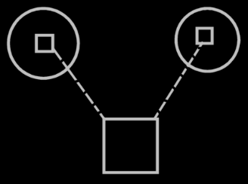

You don’t see triangles around the commands inside the circles, that would specify, that it is a separate interface: each command automatically becomes a separate interface. Just like each object also defines an interface; even though there is no triangle directly inside it, it still has an interface.

Multiple classes can support the same command
As you could see in the previous section: multiple classes, that support the same command, also support the same interface. Multiple classes supporting the same commands logically seems to create overlap in interface, but it doesn’t look like overlap in the diagram.

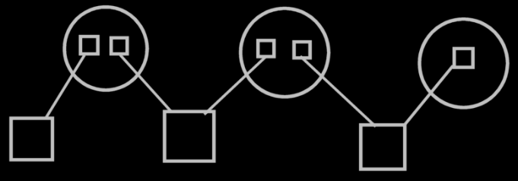

There are just multiple imaginary interface definitions (the circles), that each reference a different set of commands.
So a class referencing multiple commands, referenced by multiple classes, creates a visible interfaces of the class. The visible display of this interface is there, when you display the commands as part of a class, and not when you display the classes as parameters of the commands.

Command extending a class from another system
If two different sites define commands for the same class, this creates two interfaces for the class. If more commands for that class are defined on another site, this creates another interface for that class. This groups the commands of a class by source. That makes it so, that classes can be extended with commands very easily and suddenly, but interfaces don’t change that suddenly. Interfaces are author-bound, so one clumsy author can not mess up an interface authored by the one that authored the class himself. With commands coming from another site, it looks like the class has several command interfaces: one for each site.

It doesn’t need to be a site, that is the logical residence of a command; the logical residence of a command theoretically could also be an object. Each object, that locally defines commands for a class, creates a separate interface for that class.

That way, to extend a class with commands, you don’t need to create a derived class anymore. You can extend a class by simply creating a command that has that class as a parameter. But to extend a class with more data, you do need to create a derived class.

Preventing class’s extension with commands
A class can prevent itself from getting further extended with commands. For instance, you don’t want the class Integer to be extended with any command that uses an integer. It is a question of it being rediculous to maintain a list of all commands that uses integers. Don’t prevent a class from being extended with commands, just because you think it makes your interfaces more reliable. Class Integer can also just make it a default, that it doesn’t get further extended with commands. Some commands that use Integer, you might indeed want to see added to class integer, but you need to actively choose that then. If parameters don’t extend a class with a commands, these parameters are only shown as parameters, and not as commands inside a class definition.
> 2008-09-06 This is actually a non-dual relation.
This is basically the same issue as covered in the section Dual & Unary, which explains, when it is rediculous to maintain a backward relationship. For instance: relationships from class Integer back to any class, that uses an integer are rediculous to maintain as well.

Two design dangers
There are two design dangers here: at present day, everybody that knows his way with classes, is used to the fixed logical residence of a command inside a class, and everybody is used to not having his class be extended with commands all of a sudden. There is the danger that people using the new computer language, will give commands a fixed logical residence in a class, and turn on the option not to extend the class with commands. But you’re not supposed to do that! Not fixing a command to a class offers flexibility without unreliability. A class automatically getting extended with commands offers flexibility without unreliability. Perhaps it can be prevented, that people make these design mistakes. Perhaps by only allowing a command to be defined inside a globality, and by only being able to define it as a default, that a class does not get extended with commands, a default that can always be overridden.

Class data & class commands target definitions
A logical target class only defines data, not commands.
The data and the commands are defined by an imaginary target class. This imaginary target class is defined on a higher level than the logical target class. The class’s imaginary definition resides on a level, that’s above all the sites that define commands for the class.

The logical target class only defines data because commands are too freely definable. Other commands can be way out of sight, on a totally different site, that the class isn’t even aware of. Consider that an object in real life is defined in shape and form, but you can always invent a different use for the object: the object itself doesn’t need to change for that.

The residence of the imaginary class definition depends on the level of detail that you see in the diagram.

The target definitions of commands, as opposed to target definitions of classes, have separate target definitions, separate from the class definitions, and the class commands only indirectly refer to target definitions of commands. The picture below visualizes the concept of class data and class commands target definitions.

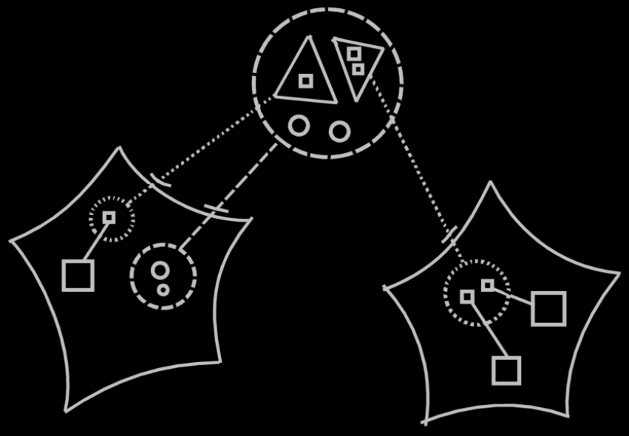

The large dashed circle at the top of the picture represents the imaginary target class, which contains both data (the little circles) and command interfaces (the triangles). The data is part of the actual class, which contains only data. The logical target of this class resides in the site on the left and is represented by a dashed circle, to which the imaginary target class points with a class line. The two command interfaces inside the imaginary class definition at the top of the diagram each point to another site’s command interface. The automatically created command interfaces aren’t real objects. they are imaginary objects. They don’t really exist as objects. Finally, the target command interface definitions on the sites, each contain references to commands defined on that site.

Looking at it like that, you can easily see that a class has several interfaces, but the interface is defined elsewhere, and an interface is definable elsewhere.

The notation above is a clear display of what is going on, but it may not conform to the eventual rules of notation of the diagrams. A discussion about the diagram notation is beyond the scope of this article. The diagram is only intended to clarify the concept.

In the diagram above you can see, that the command interface in the second site, is part of a class on the first site. But what if you zoom in on the second site:

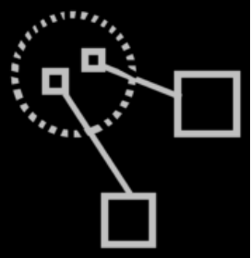

You no longer see the class itself on that level. You need to express somehow, for what class the command interface is defined. The solution is to have an imaginary reference to the class in view. If you define command for a class somewhere, then an imaginary reference to the class needs to be there:

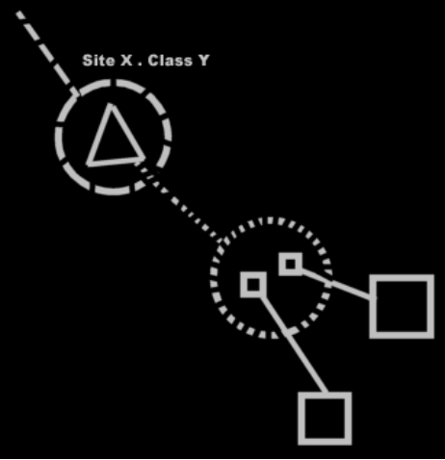

Now an imaginary reference to the class is there in the diagram, the logical target of which is specified by its name (Site X . Class Y), and it is pointing out of the diagram to indicate the target is out of sight.

Commands in class reuse with inheritance
It used to be an issue if inheritance would still be reliable, when a class’s set of commands can change so easily. The issue was: how does the ‘unreliability’ of a class’s composition affect inheritance? But now we have seen, that the total set of commands of a class may change volatilily, but a specific interface of a class does not change that volatilily. Each site specifies a separate interface of commands for the class, and these interfaces are as reliable as the site itself, and don’t change that suddenly.

The thing is: you shouldn’t really see the commands as part of the class. Only the data is part of the class. Commands are only imaginarily part of the class. In inheritance the data is inherited from the base class.
> 2008-09-06 This is not true, because if you establish a dual relation with a class on another site, the data of the class on the other site gets extended.
Also, in inheritance every command available from the base class will be available in the derived class. If interfaces or commands from the base class change or get deleted, they also get deleted from the derived class. The interfaces are just as ‘unreliable’ in the derived classes as they are in the base classes. But they’re not that unreliable, as we’ve seen. A class can easily get more interfaces, but an existing interfaces are as reliable as the site the interface is defined on.

Commands in reuse of interfaces
It also used to be an issue, whether the reuse of interfaces would still be reliable, when a class’s set of commands can change so easily. Every object symbol was able to serve as an interface, so when an object’s set of commands can change so suddenly, what good is it to use the object as an interface definition, that defines the expected interface.

The full command interface of a class may be unreliable, but a specific command interface of a class is not. You will be more likely to reuse a specific command interface of a class, rather than to borrow the whole command interface of a class as an interface.

Extensive classification with interfaces
A command implicitly creates an interface: an interface that has only one command. When commands for a class are implemented on a site, this also creates an interface for the class. These interfaces are defined automatically. Commands & classes loosely coupled creates interfaces, that already have an implementation. You are not borrowing an interface from elsewhere, and then giving it a new implementation.

commands & classes loosely coupled leads to the idea of automatic definition of interfaces. Manually defined interfaces also still exist. Rules for extensive classification through interfaces will be discussed in the article Extensive classification through interfaces. Extensive classification through interfaces is about automatic definition of interfaces, as well as manual definition of interfaces. There may be more automatic definitions of interfaces, than just the one concerned with commands & classes loosely coupled, but this will be discussed in Extensive classification through interfaces.

Conclusion
Perhaps there will be other ways interfaces will be automatically defined.
Mutuality of commands creates mutuality of interfaces,
and that different sources of commands are seen as different interfaces for a class, which makes interface of a class reliable, even though the full set of commands of the class is very variable.

More Ideas
Commands & Classes Loosely Coupled,
> Moved to Interfaces, to be thought through there.

Making a command part of multipe objects,

But in their bare form commands are independent entities. If a command has a parameter, that does not have a class, the command becomes available from any object that has access to the command, yes.
If a parameter does have a class, then the command becomes available from any object of that class.
> 2008-09-24. That’s strange. Maybe not. If a parameter does not have a class, then the object inside the commands is uniquely related to tha command. So in this setting, in order to make a command available inside the objects of a class, you have to give the parameter a class, or the command could only be called as an independent entity? Wouldn’t it?
But in essence, a command is a separate entity. Making it also part of objects and classes, is secondary to that.

Perhaps you do have to actively aquaint sites with objects with other sites, so that they either index eachother, or scan eachother, at least: scan a limited amount of the internet, not the whole internet, that is undoable.
> 2008-09-24 I have to think about this. It’s not indexed, it’s a class relation. And if changes to the class are ventilated to all the objects this happens with the help of events, but usually you’ll just use versioning to use an unchanging production version of a class.

JJ

± 2008-08

But command as a concept, as a way to establish interchangability between class commands and command parameters, also needs to subdivise the class commands into interfaces: one for each module commands are defined in.
How that is established by command as a concept is yet to be determined.
> Interfaces

JJ

Another example diagram
Class with two method interfaces from different sites

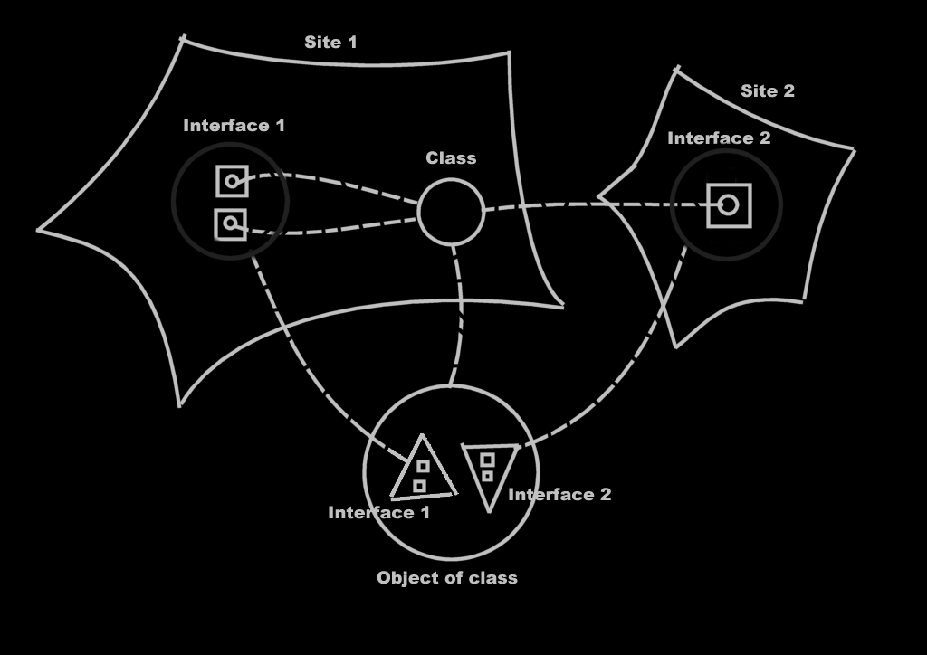

More Ideas

Access Control
On dual relations,
2008-09-06

If you establish a relation with another class, on another site,
then the other class gets a sub-item or sub-list as well.
So in that sense, an external class can change the interface
of a class on another site. So then, the interface is unreliable.
On one hand it is a welcome fact, that all new related objects
are <inzichtelijk> in the old class.
But a class can also access control the fact whether dual relations can be established to it.
In that case a class will not get a new related object when a new relation is established to it.
I think, that a dual relation has a source site. One end of the relation has authored the relation, the other relation just complied. Then the related object on the other site will have an interface of members established by another site.
Actually, this could happen dually: class A on site A has an interface of members, that reside on site B; class B on site B has an interfac eof members, that reside on site A.

JJ

Interfaces,
2008-09-06

Now that commands are object, I have the following problem.
An object can be a normal object (a cirlce) and also one that melts together
with its parent object (a triangle). For command objects I have no way to express,
that the command object melts together with its parent.
This is an issue for interfaces.

JJ

Out of the original Symbol documentation

Introduction, Interfaces
Another issue of objects is that they can have different interfaces. Consider how a employee looks to a customer and how she looks to one of her coworkers. She can do certain things for her coworker and much different things for a customer. She has two interfaces. The party that refers to her determines which interface she has, but even though both parties are referring to the same person, she means two totally different things to them.

Objects have the same ability. A type of object can have separate interfaces. Interfaces are groups of an object’s members. Another object that refers to the object decides which interface to use, or may even only be able to use a certain one of its interfaces. An object can also have just one interface, the same one for everybody.

Interfaces are distinguished by triangles.

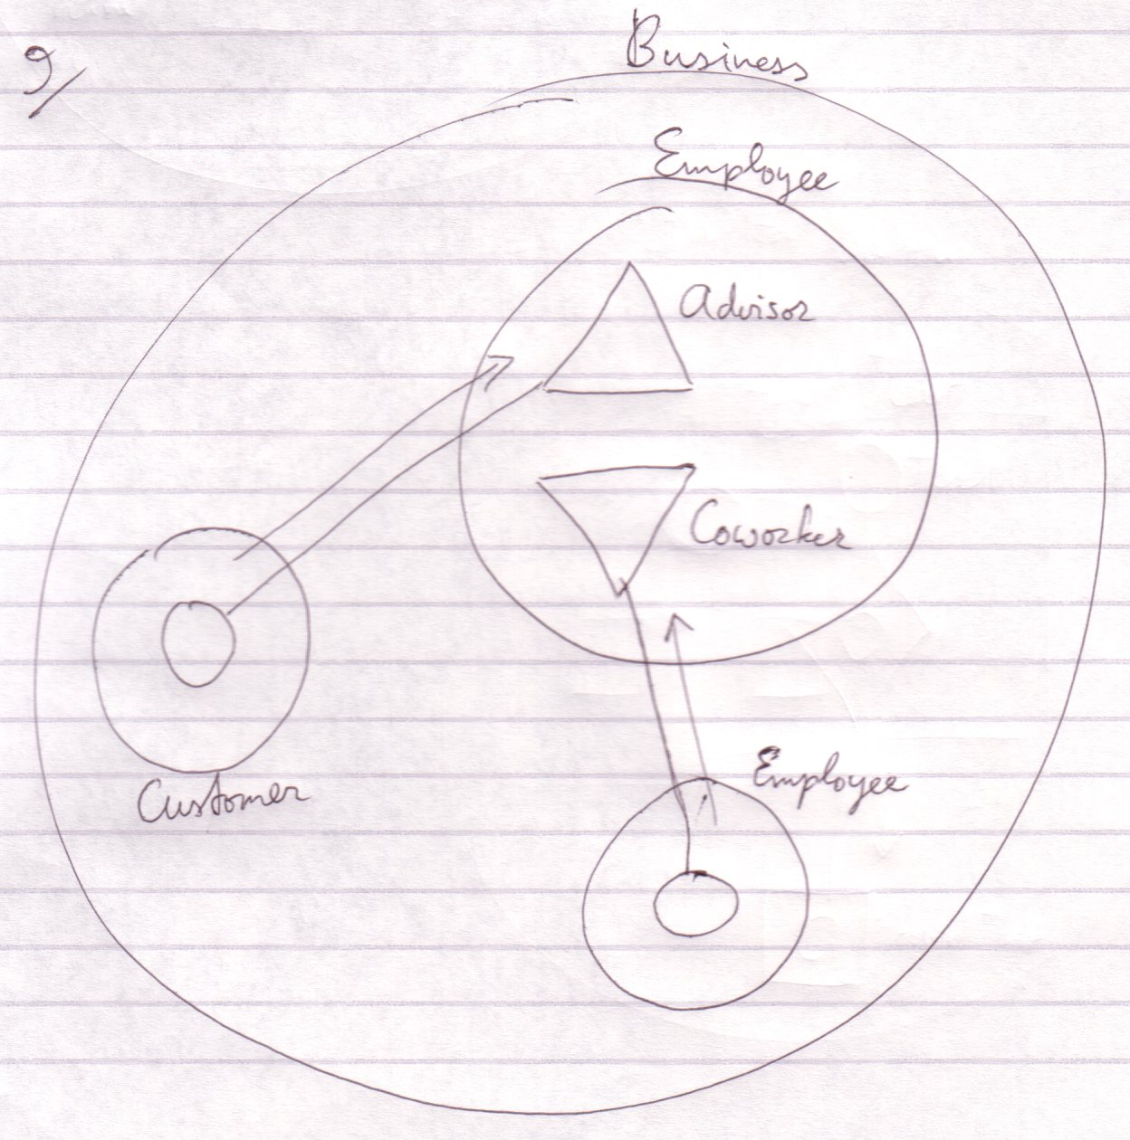

The employee is an advisor to the customer and to another employee a coworker.

Where to start when you read a diagram like this? You first read the containment structure. You start at the largest container, then the smallers ones. After that you look at the relations made by the connecting lines.

You don’t always start with the largest container. Sometimes one symbol is highlighted. Then this symbol is what the diagram is about and it's all about the aspects of this symbol. Then you start at the highlighted symbol and look around. There’s no one way of doing it.

Triangles are actually sub objects too. The difference with circles is that triangles basically melt together with their container.

Objects, be it triangles, are an excellent way to give different types mutual characteristics.

Object Basics Procedure Interface
A procedure has an interface too, consisting of all public contents of the procedure: public objects (in, out or thru) and public procedures (clauses, calls and references). A procedure can have an interface line. The target of this interface line must be a procedure, in case of which both procedures get the same parameters.


Procedure with an external interface

The interface source for a procedure can only be a procedure, not an object. Also: a procedure can not have multiple interfaces. The effect of allowing these two things can be imagined, but the usefulness of these structural possibilties is slim, while it would add a lot more rules to the Symbol Language.

For the time being, triangles can reside in a procedure, but only for the purpose of grouping procedure members. You can’t give these triangle any lines, because that would suggest that the procedure adopts all characteristics of an object.

Interfaces
Every symbol has an interface. The interface is represented by the public contents of the symbol. Anything private is the implementation of the interface.

In a normal procedure, for instance, the code lines of it are actually private and part of the implementation. Only the procedure name, its parameters and return value are public and are part of the interface.

So a symbol always has an interface: its public members.

To make two symbols have the same interface you connect them with a dotted line:



This dotted kind of line is also called an interface line, because it denotes which symbols have the same interface. The public members of both symbols are the same, but each symbol has its own implementation. The symbols are not necessarily the same type nor the same object.

This way you can give a type an already defined interface. That for instance allows objects that can work with a certain interface, to link to objects of the new type.

Editing the interface can be kind of dangerous, because if you remove an interface member, you remove all the implementations of the member in all the types that have that interface. If you do edit an interface, then the interface of the connected symbols changes simultaniously, but not the implementation.

Two Interfaces
You also have the ability to give a symbol two separate interfaces. For this, the triangle symbol is taken in use.

The following is the basic notation for a symbol that implements two separate interfaces:



A triangle represents the implementation of an interface. Triangles are, however, often called interfaces of the object. Don’t start to think that only triangles are interfaces. Any symbol can function as an interface. A triangle is the implementation of an interface.

Triangle Versus Circle
A triangle, just like the circle, is a:

- Type
- Object
- Interface source
- Creatable (explained soon)



Using a triangle instead of a circle:



Sees to it that:

- B’s members are accessed as if they were A’s own members
- You can refer to type A as if it were of type B



So a triangle is a sub object of the container, but its members are like part of the container and the container can be referred to as if it has the type of the triangle.

Member Grouping
Because a triangle basically merges with its container, it’s like you aren’t bothered by the borders of a triangle. That makes the triangle an easy way of grouping members, without harming the way you access the members.

You can also put a circle around members to group them. That changes the way you access the members, though. You’d have to qualify the access with the name of the grouping circle.

A Circle Contains But Interface Implementations
Each circle implements at least one interface. Nothing is defined outside the context of an interface implementation so inside a circle nothing else can be defined but a set of interface implementations and the interface implementations contain the rest.

Since a triangle represents an interface implementation and a circle contains but interface implementations you’d think that a circle contains at least one triangle: one interface implementation. A circle, though, is itself an interface implementation and triangles are merely used to distinguish between separate interface implementations.

A circle:



is not shorthand for:

because the triangle is its own object. The first diagram shows one object and the second diagram shows two.

Executions & Parameters

Brainstorm

→Elsewhere
Procedure Interface Restrictions
<>
A procedure has an interface too, consisting of all public contents of the procedude: public objects (in, out or thru) and public procedures (clauses, calls and references), which can also be individually referenced and called.

The interface source for a procedure can not be an object symbol. Also: a procedure can not have multiple interfaces. The effect of allowing these things can be imagined, but the usefulness of these structural possibilties is slim, while it would add a lot more rules to the Symbol Language.

For the time being, triangles can reside in a procedure, but only for the purpose of grouping procedure members. You can’t give these triangle any lines, because that would suggest that the procedure adopts all characteristics of an object.

The procedure has no interface genericity. <A word not introduced yet here. <You can’t redirect the interface of a triangle inside a procedure either, because this would suggest that a procedure gets object characteristics. This is a restriction of a triangle directly inside a procedure symbol. >

<I think I’m totally nervous about public procedure clauses. And that’s why I forbid interface redirection for triangles in procedures here. I should allow it. The only thing disallowed is interface genericity, because that would suggest that a triangle in a procedure can point to a procedure symbol.

Hmmm… shit.>
<A lot isn’t right in what I just said there>

< The rules I will suggest in this section can change the Procedure Basics : Procedure Interface section. >

Other
Er moet ergens nog in dat een procedure een interface heeft. En misschien moet een procedure daarom ook een interface line krijgen.

Brainstorm
J Code Access Controllers and Interfaces.
------------------------------------------------

You should be able to group symbols inside a special symbol that controls the access for all the directly contained symbols. An idea is to make a special symbol to control the access for all the directly contained symbols. What pops into my head now is: since the triangle would then stand for interface, each member with the same access controller could belong to the same interface. Therefore, an interface symbol (triangle) could be used to group these symbols and the interface symbol gets the access controller instead, which applies it to all directly contained symbols.

Groeperingssymbool op basis van wat een client object gebruikt. De interface indeling is op die manier een beetje automatisch. Als je geen interface indeling hebt, dan kun je toch zien wat de verschillende clients gebruiken en misschien voor het overzicht toch een interface indeling gebruiken.

Interface
< 2008-10-10 Old >
I said a triangle was an interface. Eigenlijk is de interface een hoop functie referenties die ingevuld moeten worden. Dan zou het zo zijn dat alle members in een driehoek door zouden moeten refereren naar members binnen de cirkel. Eigenlijk moet ik een driehoek zijn eigen syntax laten hebben. Een driehoek krijgt een interface klasse. Deze kan een cirkel zijn of driehoek. De driehoek krijgt de publieke en vriendschappelijke inhoud van de interface klasse, maar niet de prive inhoud, welke de implementatie omvat. Dus de implementatie ontbreekt. Je kunt deze of zelf invullen of je creeert de implementatie door de driehoek te creeeren met een bepaalde implementatie klasse, waardoor je inheritance bewerkstelligt. Je kunt evengoed de verwijzing van de driehoek veranderen om de implementatie te delegeren. De driehoek heeft altijd de holle vorm van zijn interface klasse, maar de klasse en het object van zijn verwijzing. Als je hem creeert dan heeft hij geen verwijzing.

Een interface heeft een interface, implementatie en object. De klasse is de interface, de implementatie zou ook een klasse moeten zijn en het object dan de referentie.
Heeft de driehoek een extra referentie dan? Interface, implementatie en object?

Maar dan heeft een cirkel dat ook, want die representeert… oh, de gezamenlijke interface. De driehoek kan ook zelf de interface klasse zijn en de interface en de implementatie.

Changing a Reference or Type
An object assignment procedure gets the source as an argument, and another argument that specifies the symbol to reference. The symbol to reference needs to be the same interface …
A reference has a fixed interface, but can be point to or be of any type as long as you reference the same interface.
For that, changing the type of a reference is permited

Changing the type of a symbol is not permitted, be it that the same interface of

2004,

You might not want to be able to reference a type’s full interface, but only the sub interfaces, so it would be more like com. Oh, this actually seems an access control issue.

JJ

2004,

Symbol has to be revised. It doesn’t distinct types and interfaces well. It doesn’t work well with interfaces. Like how do I pass a pointer one interface of an object to a method?

JJ

2004,

A type has one interface by default: the default interface, which is formed by every public member of the type. A type can also have multiple interfaces, which are groups of its members. The default interface includes all members of these separate interfaces.

JJ

Terms
Interface
Implementation

-----

-----

2008-10-13,

2004: “Methods abstract other methods”
Perhaps Interfaces should cover a lot of design patterns as such, even though they do not directly have to do with interfaces

JJ

Similarly, an object symbol can control its own interface:

But if it has an interface line, its interface is bound to that of its interface line target. The symbol is regarded an interface implementation, while the target interface serves as the interface.


B is the interface, A is an implementation of it.

